HOMEWORK: 3rd grade 25th September

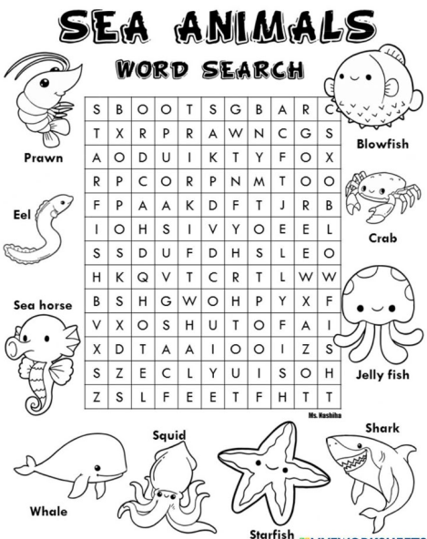

Write the sea animals and color.

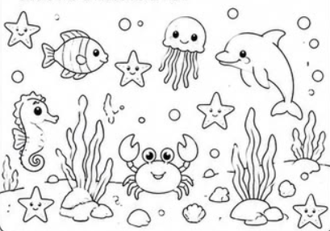
STARFISH
_________________________________
_________________________________
_________________________________
_________________________________
_________________________________

Complete the words.
