
Homework nº 6
* Use a dictionary and find the past form of a following verbs, then complete the sentences.

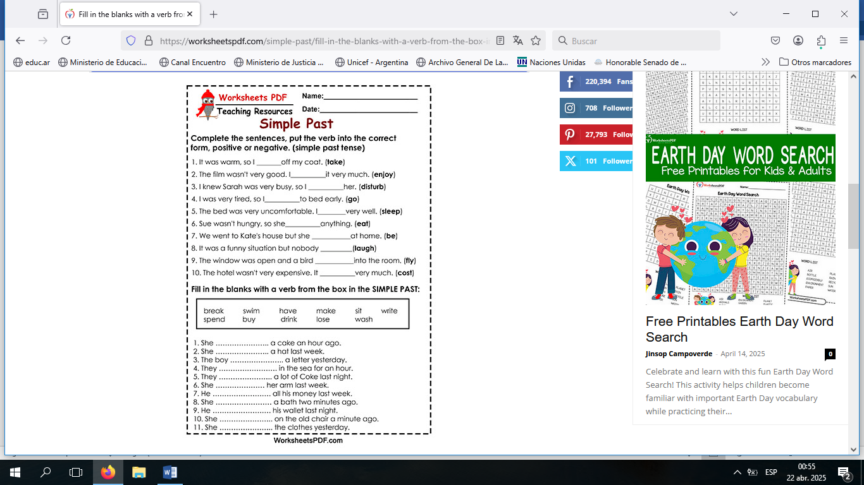
*Write in a short paragraph What you did yesterday.
____________________________________________________________________________________________________________________________________________________________________________________________________________________________________________________________________________________________________________________

Have a nice week!!!

