HOMEWORK: 3rd grade 30th April

- Write some or any.
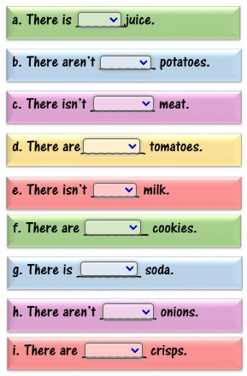
- Complete with THERE IS, THERE ARE, THERE ISN’T, THERE AREN’T, SOME or ANY.
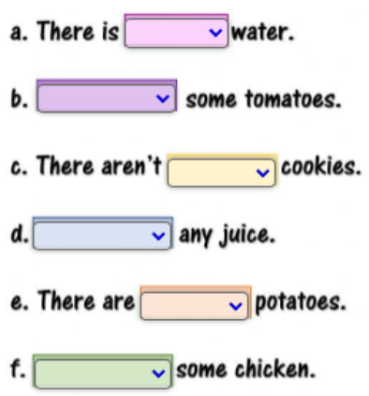
- Write sentences using THERE IS/ARE SOME…
