

MY ENGLISH HOMEWORK: 30/04 - 3° GRADE – SIMPLE - 2026
Miss Virginia Grillo

- REVISION UNIT1: Routine – The time

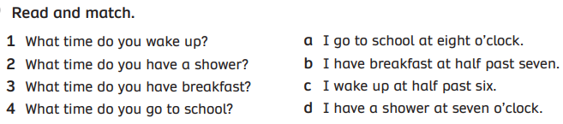
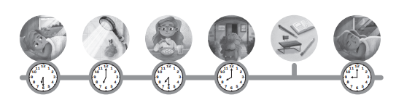

2) LOOK AND WRITE THE TIME: O’CLOCK – HALF PAST

- 5:30 : It’s ……………………………. five.
- 10:00 : It’s ten ………………………….
- 3:00 : It’s three ………………………..
- 8:30 : It’s ………………………………. eight.

