Tarea 13/03/26
Fecha de entrega: lunes 16/03
Matemática
- Completa la ficha 2 del fichero “B” - ¿Te acordás? -.
Lengua
- Pasa a cursiva los siguientes tantanes.
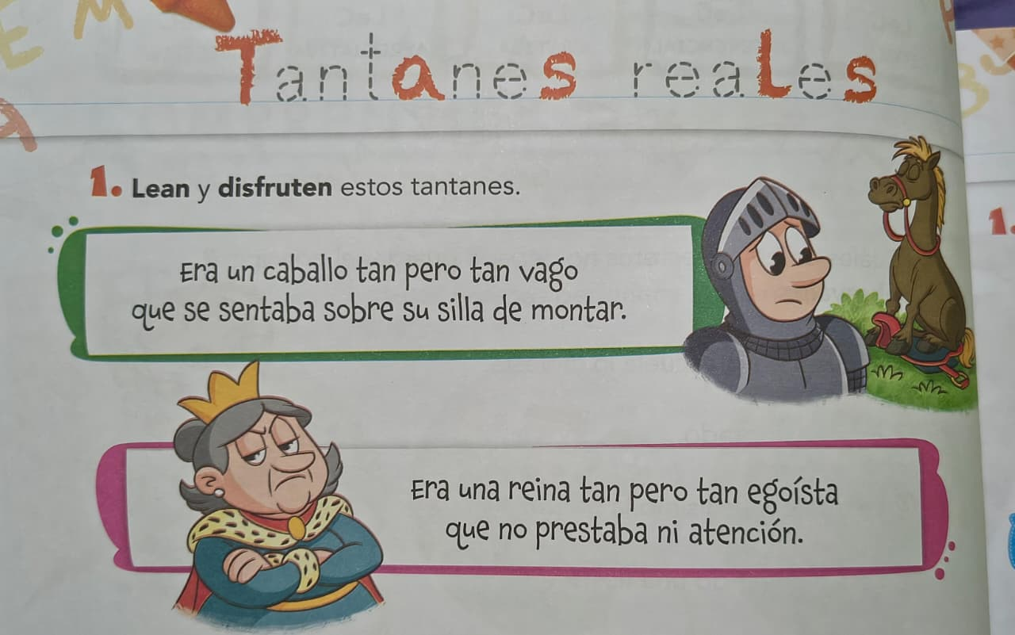
_______________________________________________________________________________________________________________________________________________________________________________________________________________________________________________________________________________________________________________________________________________________________________________________________________________________________________________________________________________________________________________________________________________________________________________________
Notif:

