HOMEWORK: 3rd grade 27th March

- Look and complete with the correct word.
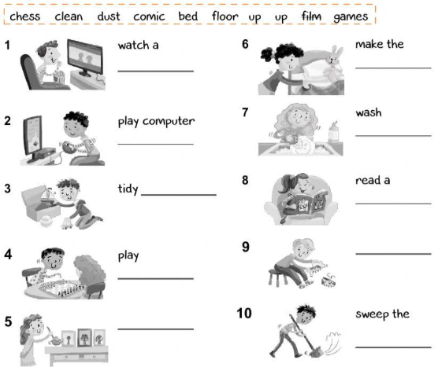

- Write the correct number in the food pyramid. Draw some food.
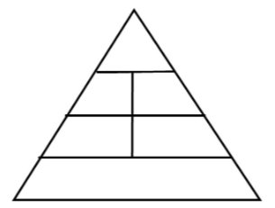
1
- FRUITS AND VEGETABLES.
- BREAD, CEREAL, PASTA, RICE, ETC.
- FATS, OILS, SWEETS.
- DAILY PRODUCTS.

