

MY ENGLISH HOMEWORK: 27/03 - 3° GRADE – SIMPLE - 2026
Miss Virginia Grillo

- RISE AND SHINE 3: HAS GOT – HASN’T GOT
- Look at the picture. Then read and complete the sentences. (el vocabulario se encuentra en la pág. 6 Student´s Book.)

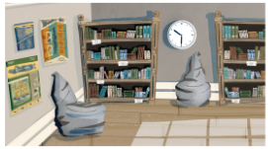

- This is the ……………………………………………………… (Reading corner / courtyard)
- It …………………………………. (has got / hasn’t got) two beanbug.
- It has got ……………………………….. (computers / posters)
- Biscuit, the dog, …………………… (is / isn’t) inthe Reading corner.

