HOMEWORK FIRST GRADE

- WRITE
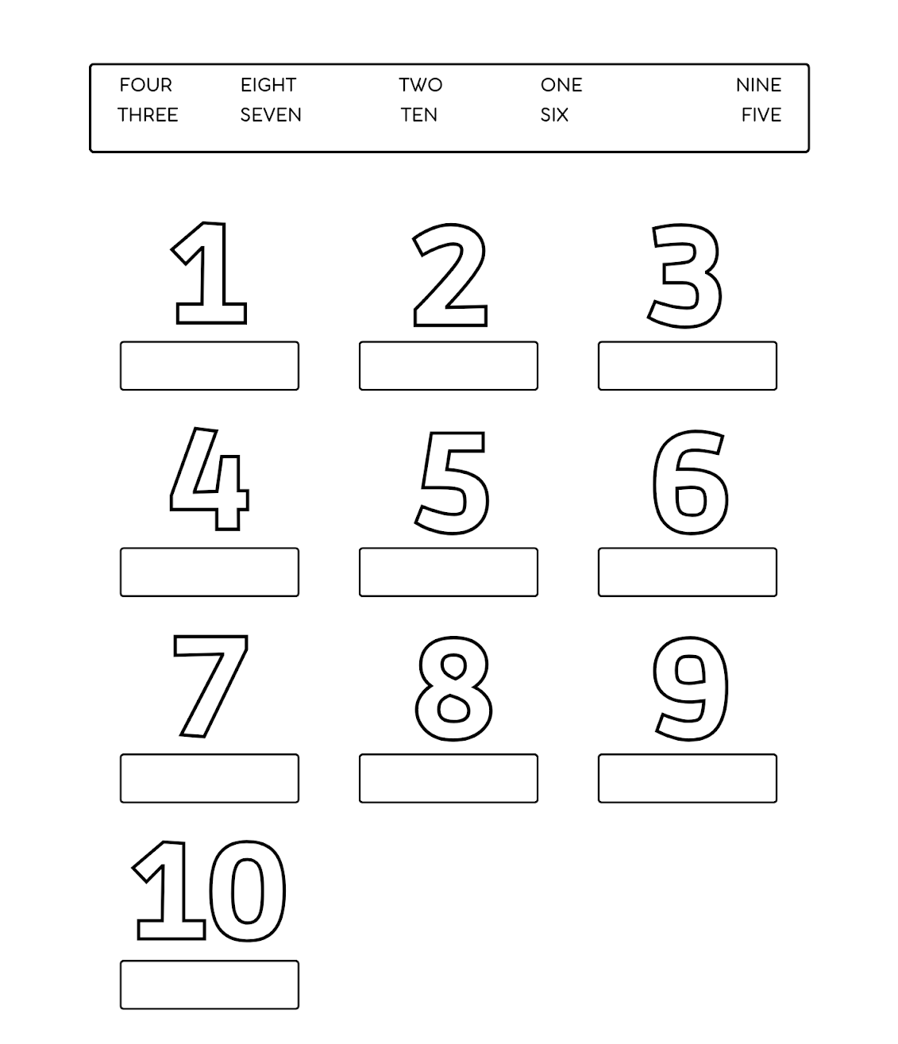

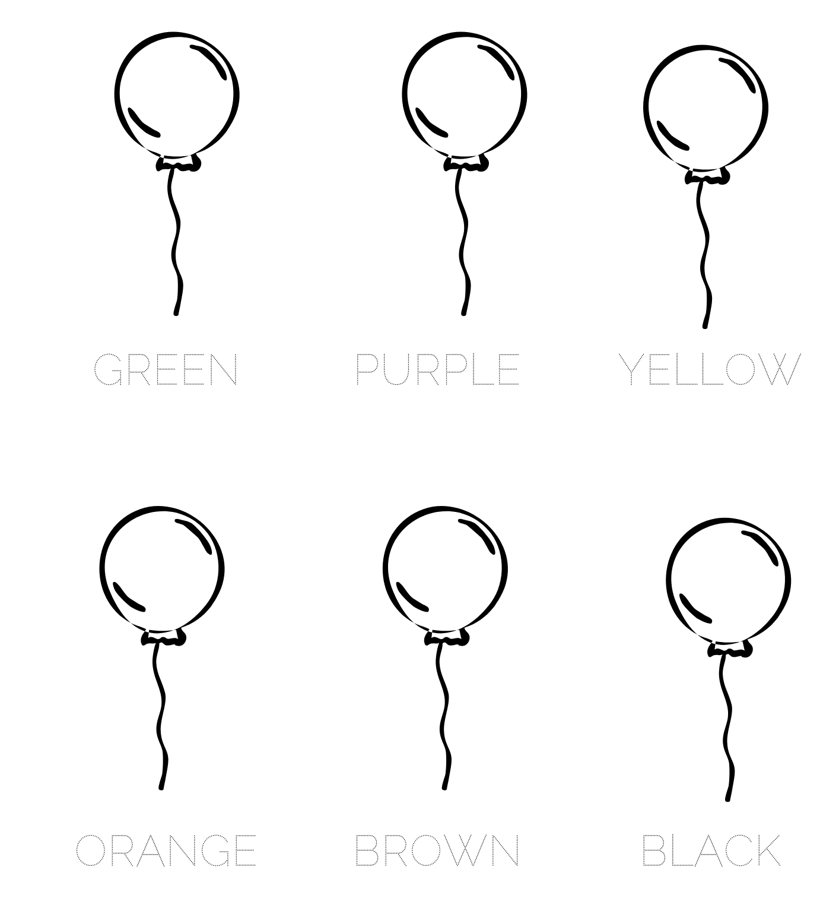
- TRACE AND COLOUR

