**Homework – 5th Grade**

- Teacher: Mr. Dionel David Arnaldi

- Date: Friday 17th October 2025

1. Complete the crossword with the vocabulary from Units 5, 6 and 7.

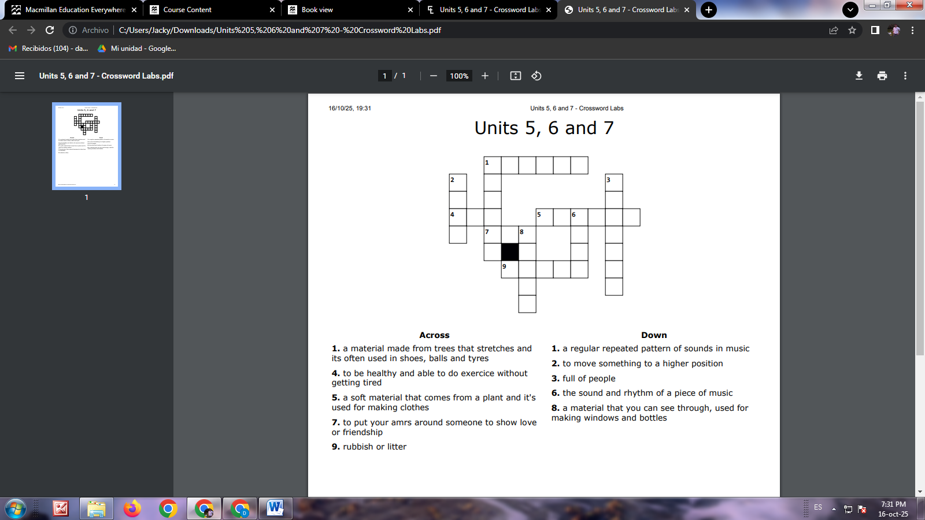

1. Complete the sentences with will or going to with the verbs in parentheses
2. Look at those clouds! It ______________ (rain).
3. I think she ______________ (be) a great teacher.
4. We ______________ (visit) our grandparents next weekend. It’s already planned.
5. I’m tired. I ______________ (go) to bed early tonight.
6. He ______________ (probably / call) you tomorrow.
7. They ______________ (not / play) football today. They forgot the ball.
8. Watch out! You ______________ (fall).
9. **Change the sentences from active voice to passive voice (Present Simple)**

**Example:**  
Active: The chef cooks the meal.  
Passive: The meal **is cooked** by the chef.

1. She writes emails every day. ___________________________________________
2. The students read many books. ___________________________________________
3. He washes the car on Sundays. ___________________________________________
4. They clean the classroom. ___________________________________________
5. We open the shop at 9 a.m. ___________________________________________
6. The teacher checks the homework. ___________________________________________
7. People speak English all over the world. ________________________________________
8. The mechanic repairs cars. ___________________________________________
9. My mother makes delicious cakes. ___________________________________________
10. They deliver letters in the morning. ___________________________________________