**MY ENGLISH HOMEWORK: 17/10 – 4° GRADE - SIMPLE – 2025**

**Miss Virginia Grillo**

REVISION: Food: Countable and Uncountable

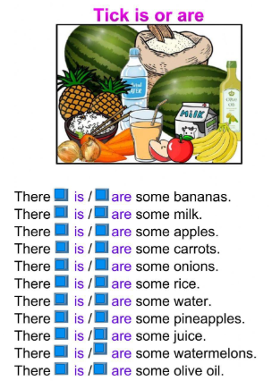

LET’S PLAY ONLINE!

Ir al enlace: <https://wordwall.net/es/resource/4384767/there-is-there-are-food>

(les va a aparecer esta pantalla, denle PLAY: Choose the correct option)

