**MY ENGLISH HOMEWORK: 09/10 – 3° GRADE - SIMPLE – 2025**

**Miss Virginia Grillo**

REVISION: Unit 5

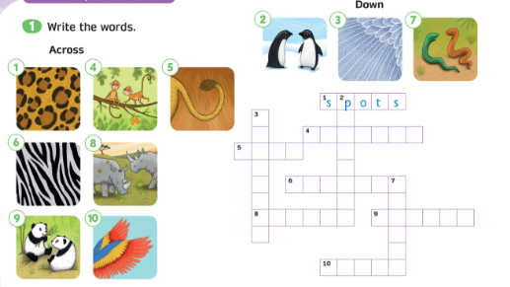

1. Choose animals: lions – zebras – monkeys - tigers - pandas - snakes.
2. Read and complete the sentences.

