**MY ENGLISH HOMEWORK: 17/10 – 2° GRADE - SIMPLE – 2025**

**Miss Virginia Grillo**

REVISION: New activities.

LET’S PLAY ONLINE!

Ir al enlace: <https://wordwall.net/es/resource/88994000/rise-shine-2-unit-4-new-activities-speed-quiz> (les va a aparecer esta pantalla, denle PLAY: Choose the correct option)

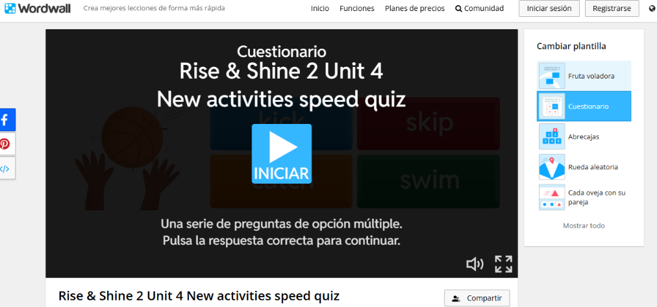

2) LOOK. READ AND CIRCLE.

3) THEN WRITE: ***CAN*** or ***CAN’T***

