**MY ENGLISH HOMEWORK: 09/10 – 2° GRADE - SIMPLE – 2025**

**Miss Virginia Grillo**

REVISION: Unit 4

1. Find and write.
2. Then tick the actions YOU can do.

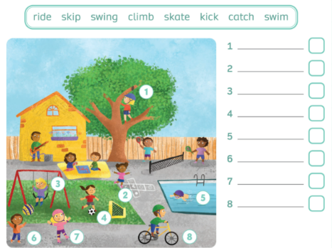

1. Write 4 sentences from ex.2. CAN or CAN’T

For example:

*I CAN SWIM.*

*………………………………………………………………….*

*………………………………………………………………….*

*…………………………………………………………………*

*………………………………………………………………..*