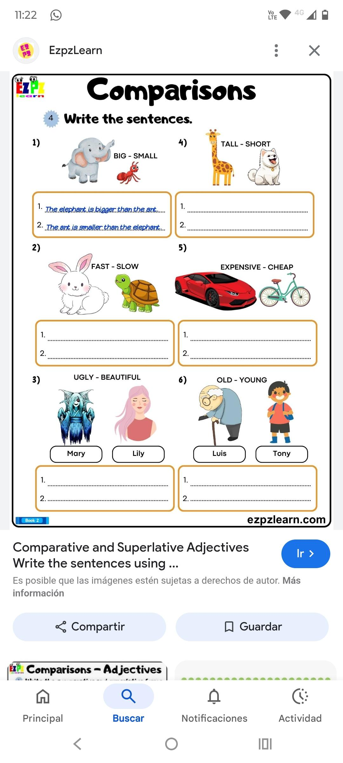**Homework: 3rd grade A** – 19th September