**MY ENGLISH HOMEWORK: 19/09 – 6° GRADE - SIMPLE – 2025**

**Miss Virginia Grillo**

REVISION: Unit 2: Comparative and Superlative: Long and short adejctives.

*LET’S PLAY A GAME!!!*

Copiar el enlace en la barra del buscador:[*https://wordwall.net/es/resource/28802853/superlativecomparative*](https://wordwall.net/es/resource/28802853/superlativecomparative)

*Les va a aparecer esta imagen. Dar PLAY y a jugar el Quiz!!!*

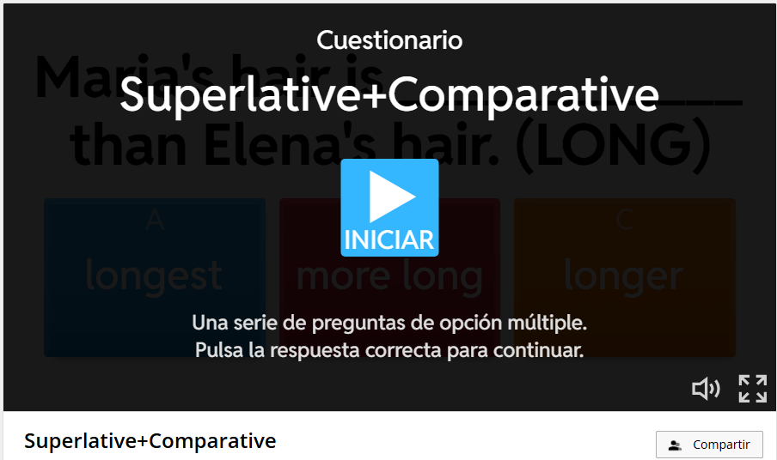

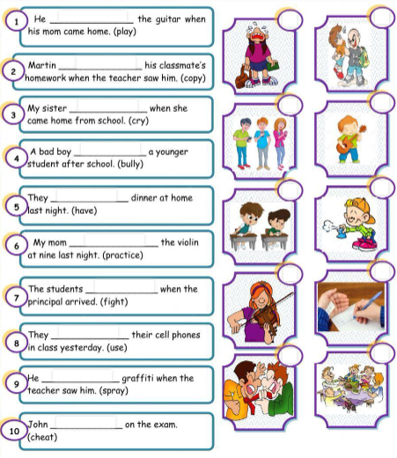REVISION: Unit 3: Unit 3: Past progressive.

