**HOMEWORK SEPTEMBER - 1 ° A**

1- READ AND CIRCLE THE CORRECT OPTION

1. SPIDERS HAVE GOT WINGS / LEGS
2. SNAKES HAVE GOT ARMS / TAIL
3. DOGS HAVE GOT TWO TAILS / EYES
4. CATS HAVE GOT FOUR EARS / LEGS
5. WE HAVE GOT MOUTH / BEAK
6. WE HAVE GOT TWO ARMS / WINGS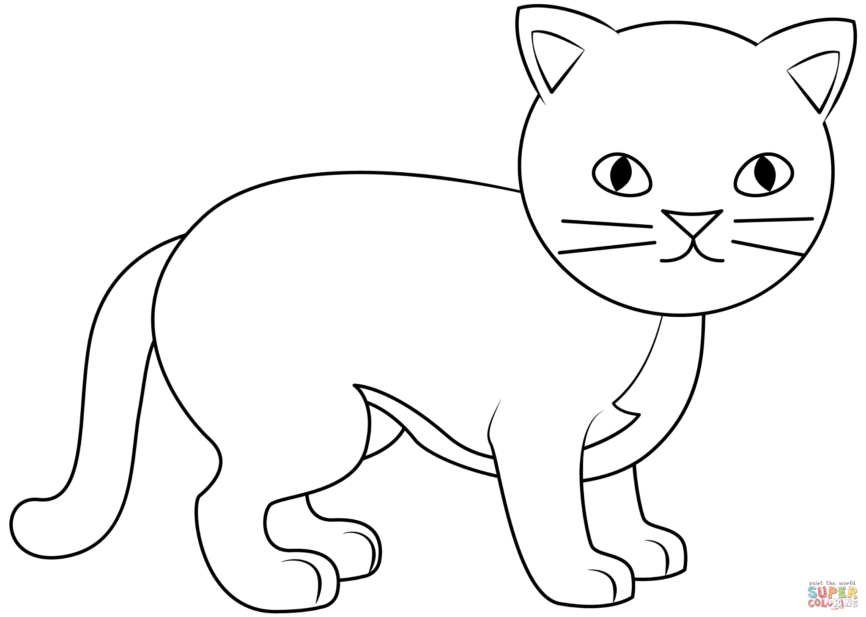

2- READ AND COLOUR

* CATS HAVE GOT TWO BLUE EYES
* THEY HAVE GOT BROWN TAIL
* THEY HAVE GOT FOUR BLACK LEGS
* THEY HAVE GOT ONE PINK NOSE
* THEY HAVE GOT TWO YELLOW EARS

3- COMPLETE

* COWS HAVE GOT TWO _________.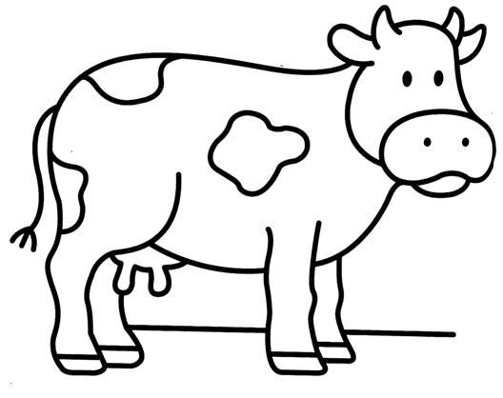
* COWS HAVE GOT FOUR ________.
* THEY ______ ________ A HEAD.
* THEY ______ ________ A TAIL
* THEY HAVEN’T GOT BEAK.
* THEY _______ _______ WINGS.

Señor Tutor:

Comunico por este medio que la próxima semana tendremos la Evaluación de tramo de **READING AND WRITING** el día  **Lunes 22 de septiembre.**

Además, el día Jueves 25 realizaremos una trabajo de SCIENCE por lo que cada alumno deberá traer para el dia Lunes:

**Una imagen impresa o foto de ellos y una de su mascota o de su animal preferido.**

Sin otro particular lo saluda atentamente.

Miss Lucia Ganoza