**Homework: 3rd grade A** – 29th August

* Student book: page 57. Activity 3 (**Do the activity in the book)**

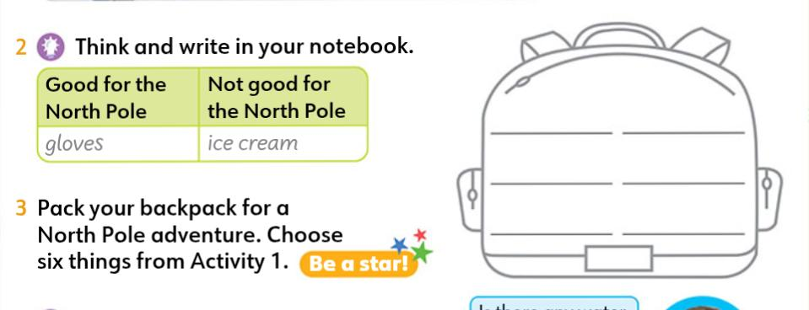



* Then write sentences about your backpack (Write them **in your folder**)

For example:

1. In my backpack there are some ______________
2. In my backpack there isn’t any ______________
3. In my backpack there is a/an ______________