**Homework: 3rd grade A** – 15th August

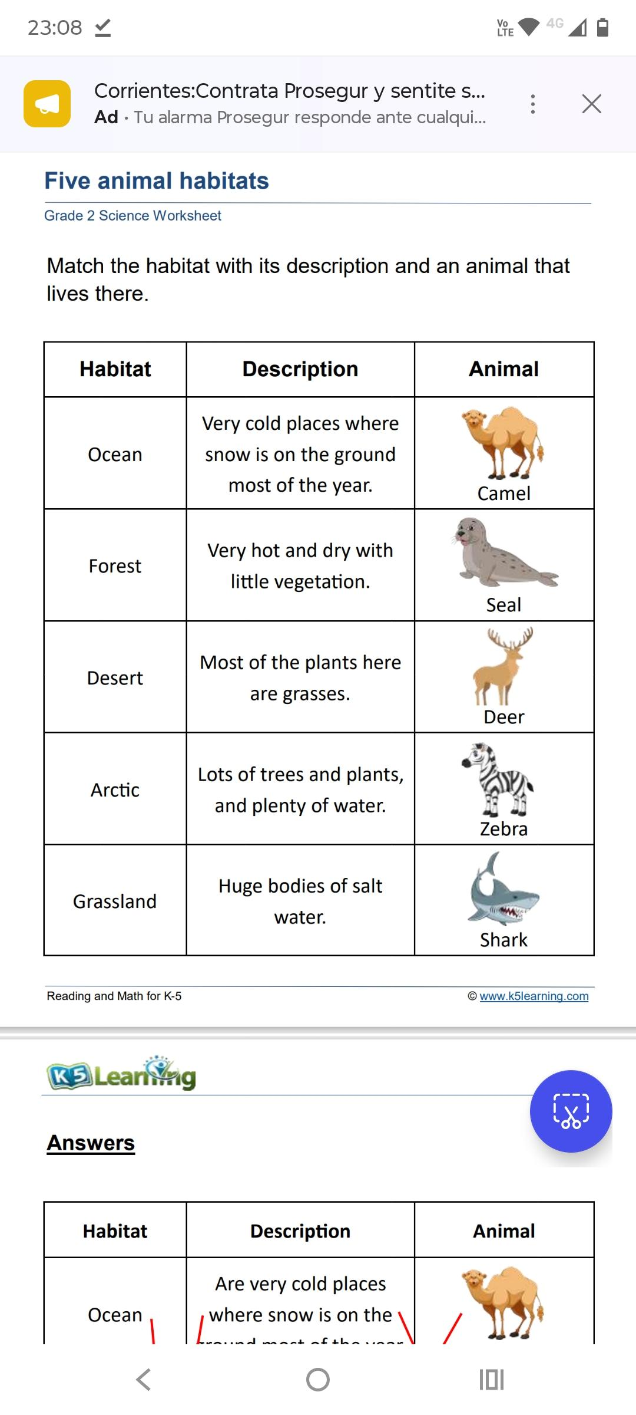



|  |
| --- |
| **Habitats** |
| **Savanna** |
| **Polar region** |
| **Forest** |
| **Ocean** |
| **Desert** |