**MY ENGLISH HOMEWORK: 22/08 – 6° GRADE - SIMPLE – 2025**

**Miss Virginia Grillo**

REVISION: Unit 2

1. Read the text. Answer ex.1.
2. In Ex.2: Underline the adjectives to describe buildings.

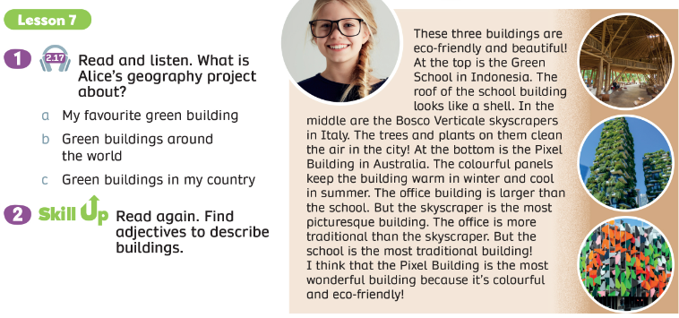

1. Read the text: These three cities are amazing!
2. Write the adjectives the writer uses to describe places.



 

 

 

