**MY ENGLISH HOMEWORK: 08/08 – 6° GRADE - SIMPLE – 2025**

**Miss Virginia Grillo**

REVISION: COMPARATIVESAND SUPERLATIVES

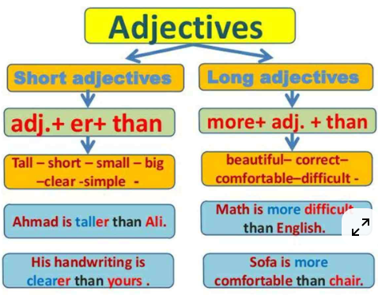

1. READ. COMPLETE THE SENTENCES USING COMPARATIVE AND SUPERLATIVE:

