**MY ENGLISH HOMEWORK: 22/08 – 2° GRADE - SIMPLE – 2025**

**Miss Virginia Grillo**

REVISION: FARM ANIMALS

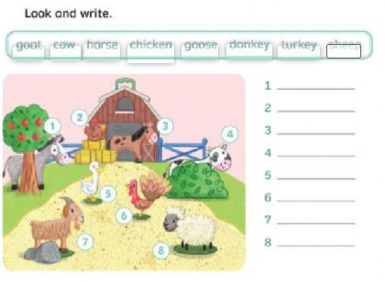

2) LOOK AT THE PICTURE.

3) ANSWER ‘TRUE’ OR ‘FALSE’:

*THERE’S DONKEY BEHIND THE FENCE. ___________*

*THERE IS A COW BEHIND THE BUSH. __________*

*THERE IS A GOAT BEHIND THE ROCK. ____________*

*THERE’S A CHICKEN BEHIND THE TREE. __________*