**HOMEWORK - 1 ° A**

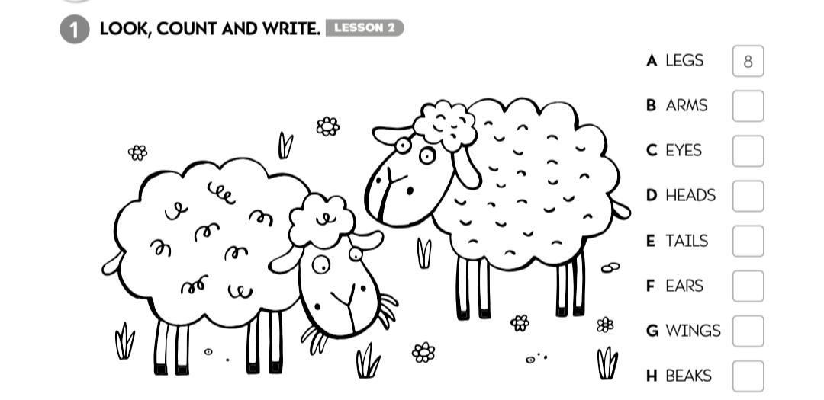

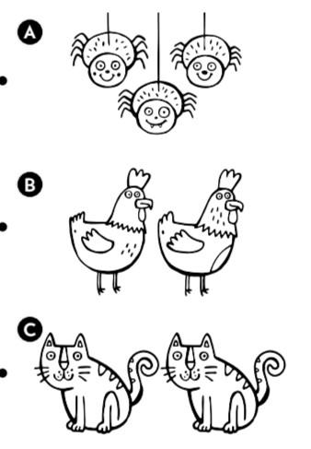

2- READ AND MATCH

THEY’ VE GOT 2 WINGS.

THEY'VE GOT 1 BEAK.

THEY'VE GOT 2 EARS.

THEY ‘VE GOT 1 TAIL.

THEY’ VE GOT 8 LEGS.

THEY’VE GOT 2 EYES