**TAREA**

**PRIMER GRADO “A”**

1. RESOLVER LAS SIGUIENTES SUMAS Y RESTAS:

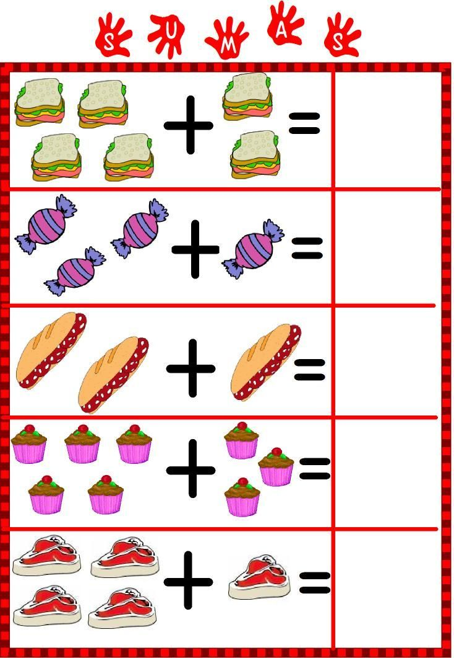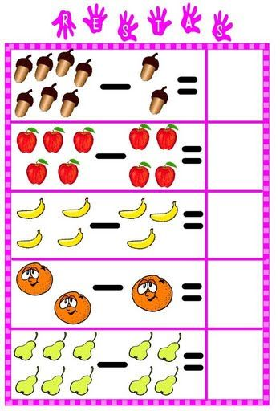

1. ESCRIBIR LA FAMILIA DEL 50:

|  |  |  |  |  |  |  |  |  |  |
| --- | --- | --- | --- | --- | --- | --- | --- | --- | --- |
|  |  |  |  |  |  |  |  |  |  |

1. ORDENAR DE MENOR A MAYOR: 59-31-58-45

|  |  |  |  |
| --- | --- | --- | --- |
|  |  |  |  |

1. ESCRBIR DOS PALABRAS QUE COMIECEN CON LA LETRA R:

……………………………………………………. …………………………………………………….

1. COLOREAR:

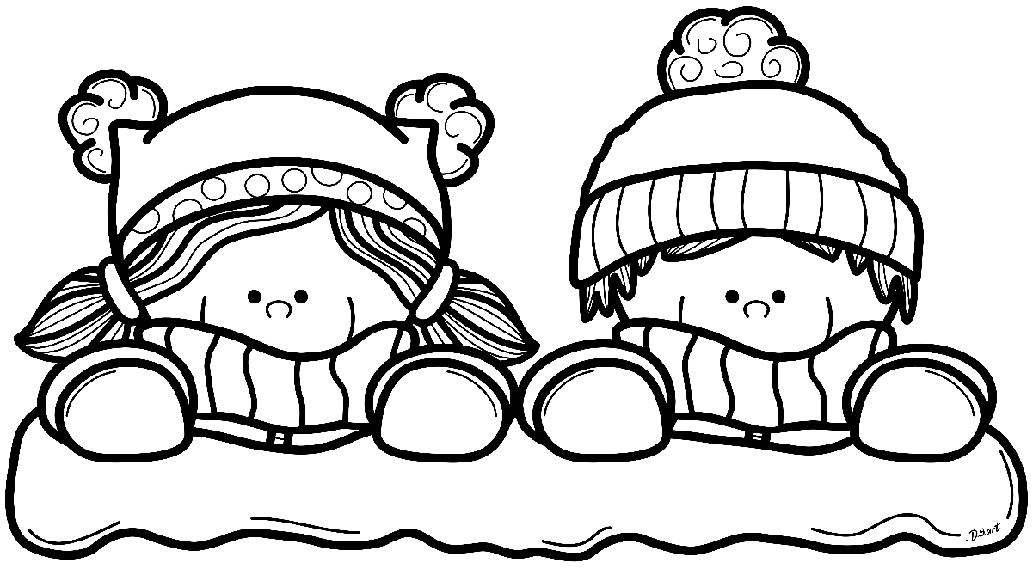

**¡¡¡¡FELICES VACACIONES DE INVIERNO!!!!**