**HOMEWORK: 2do A**

**11th July**

1. **Complete with the words in the box.**

**don’t play - stretch - don’t do - cook - go**

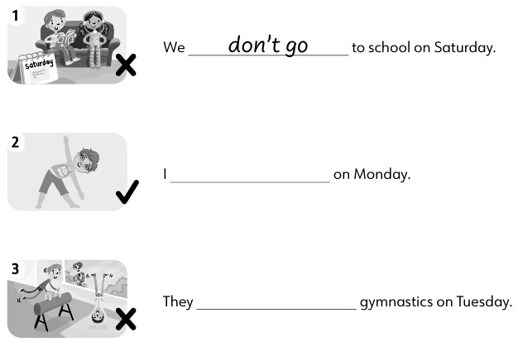

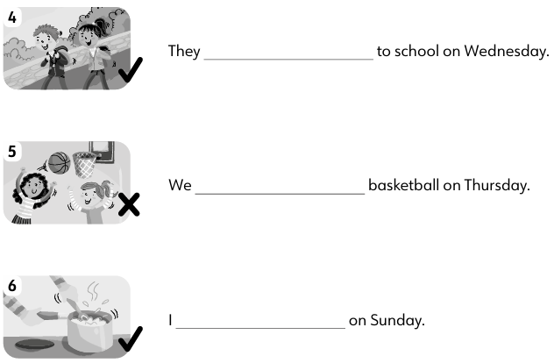

**2.Look and write sentences.**

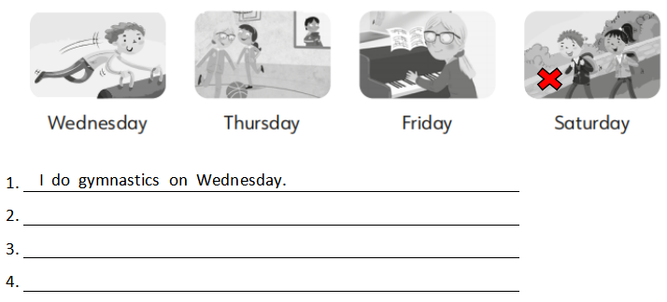

**3.Order the sentences.**

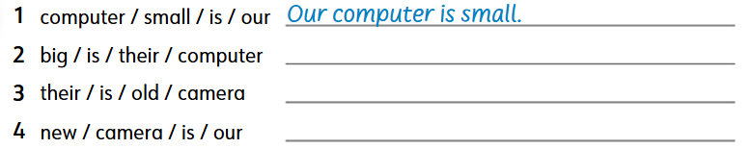

1. **Write the numbers.**

**1: 2: 3: 4:**

**5: 6: 7: 8:**

**9: 10: 11: 12:**

1. **Complete with the time: “It’s one o’clock.”**

