**MY ENGLISH HOMEWORK: 11/07 – 6° GRADE - SIMPLE – 2025**

**Miss Virginia Grillo**

REVISION: UNIT 2

1. READ THE TEXT.
2. READ AND ANSWER THE QUESTIONS.

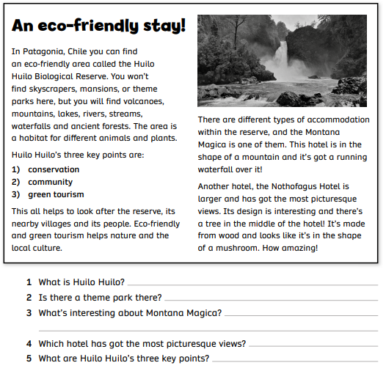

HAPPY WINTER HOLIDAYS!!!