**MY ENGLISH HOMEWORK: 11/07 – 4° GRADE - SIMPLE – 2025**

**Miss Virginia Grillo**

REVISION: UNIT 3

* *TRY TO REMEMBER THE PLACES.*
* *DON’T USE THE BOOK.*

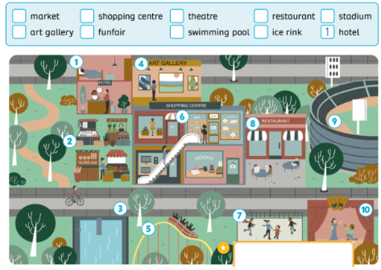

HAPPY WINTER HOLIDAYS!!!