**MY ENGLISH HOMEWORK: 11/07 – 3° GRADE - SIMPLE – 2025**

**Miss Virginia Grillo**

REVISION: UNIT 4

* *Look at your Pupil’s book, pages 42 and 43.*

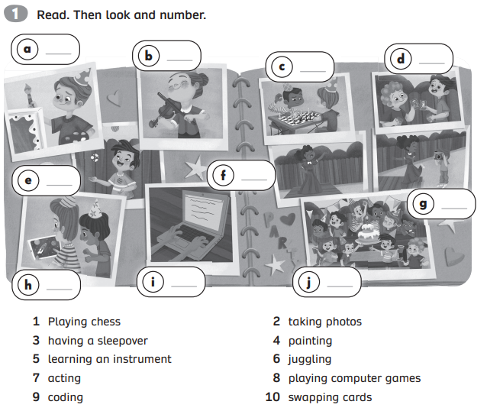

HAPPY WINTER HOLIDAYS!!!