**MY ENGLISH HOMEWORK: 11/07 - 2° GRADE - SIMPLE – 2025**

**Miss Virginia Grillo**

REVISION: UNIT 3

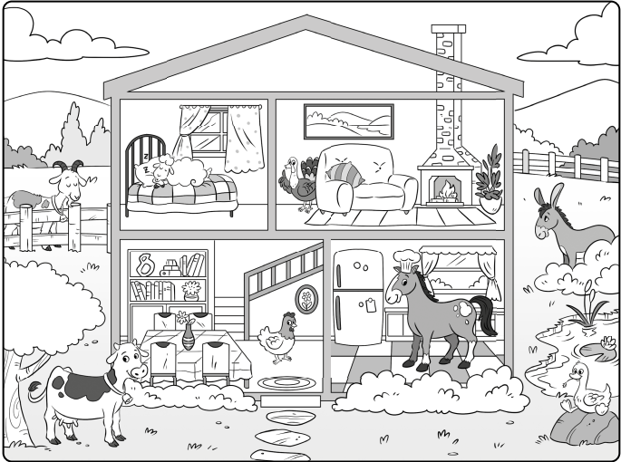

1. LOOK AT THE PICTURE.
2. READ AND ANSWER ***TRUE***OR ***FALSE.***
3. THE ***DONKEY*** IS INTHE ***BEDROOM. _________________***
4. THE ***COW*** IS IN THE ***GARDEN. ______________***
5. THE ***CHICKEN*** IS IN THE  ***LIVING ROOM. ______________***
6. THE  ***GOOSE*** IS IN THE ***KITCHEN***. _____________
7. THE ***SHEEP*** IS IN THE ***BEDROOM.*** ___________
8. THE ***DONKEY*** IS IN THE ***GARDEN***. __________
9. THE ***HORSE*** IS IN THE ***KITCHEN***. ______________

HAPPY WINTER HOLIDAYS!!!