**HOMEWORK 11th JULY- 1 ° A**

1. READ AND COLOUR.

* I’VE GOT A BLUE SCOOTER
* I’VE GOT A RED SKIPPING ROPE
* I’VE GOT A YELLOW ROBOT
* I’VE GOT A PINK TEDDY
* I’VE GOT A GREEN SKATEBOARD
* I’VE GOT A PURPLE BOAT

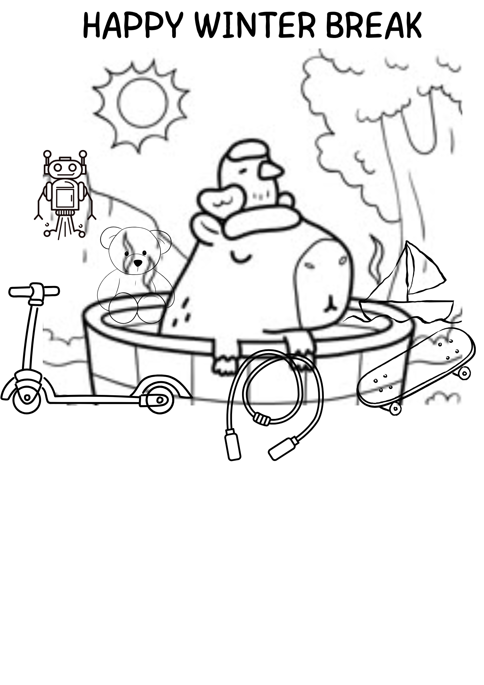

1. WRITE THE NAME OF THE ANIMALS

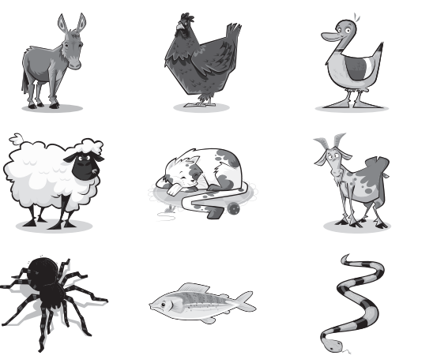

D________

CH ________

D ______

SH ________

_________

G _______

S __________

_________

S __________

1. WRITE THE NUMBERS AND COLOURS

|  |  |  |  |
| --- | --- | --- | --- |
| **1** |  |  |  |
| **2** |  |  |  |
| **3** |  |  |  |
| **4** |  |  |  |
| **5** |  |  |  |
| **6** |  |  |  |
| **7** |  |  |  |
| **8** |  |  |  |
| **9** |  |  |  |
| **10** |  |  |  |

1. LOOK AND WRITE

EXAMPLE: THREE RED RULERS.

