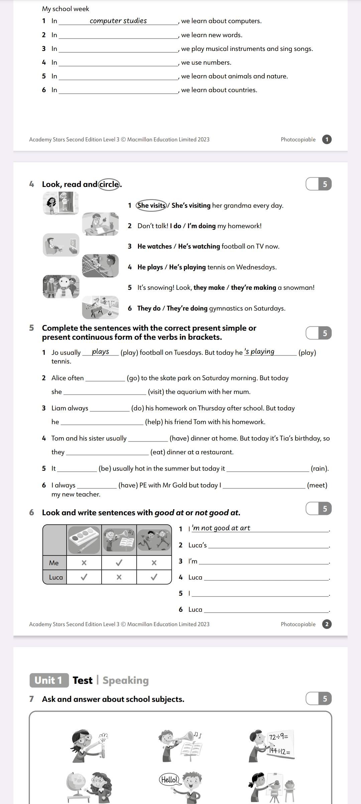**Homework: 3rd grade A** – 13th June

* Read and complete the blog. Use **present simple, chores and free time activities.**

**My family**

I live with _________________________________________________________

We live in _______________________. Our house / flat is __________________

**My routine**

In the morning, I _________________________________. Then, I ___________

_________________________.

In the afternoon, I ________________________________. After that, I ________

__________________________. At night, I ______________________________.

**My weekend**

I love the weekends! In the morning, ____________________________________.

In the afternoon, ____________________________________________________

At night, __________________________________________________________