**HOMEWORK: 2do A**

**19th June**

1. Look and write.

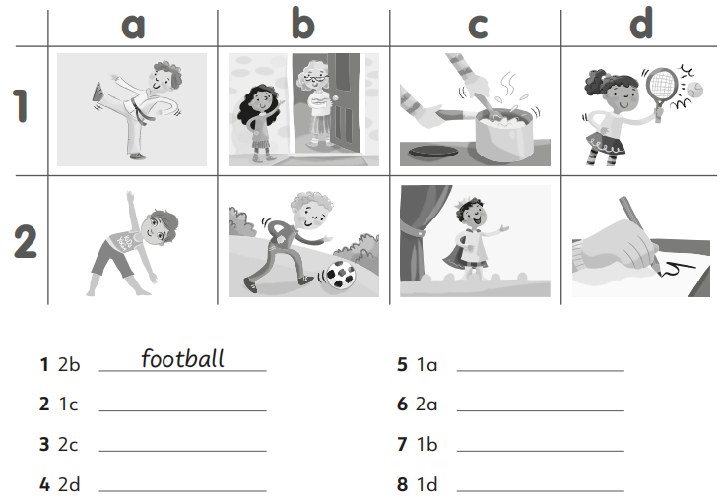

1. Complete.

