**HOMEWORK: 2do A**

**13th June**

1. Look and write OUR or THEIR.

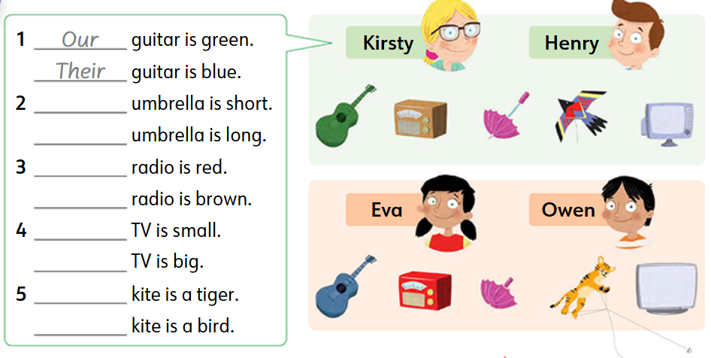

1. Order the words.

