**MY ENGLISH HOMEWORK: 27/06 - 6° GRADE - SIMPLE – 2025**

**Miss Virginia Grillo**

REVISION:

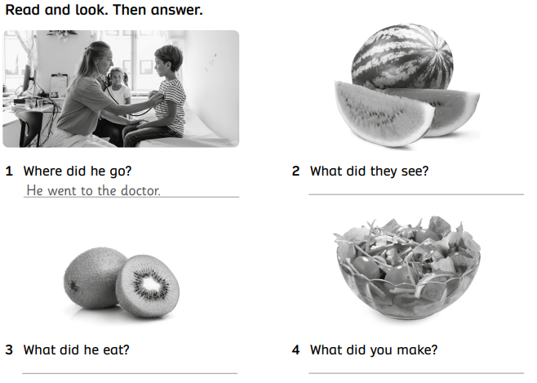

READING COMPREHENSION:

1. Read the dialogue:

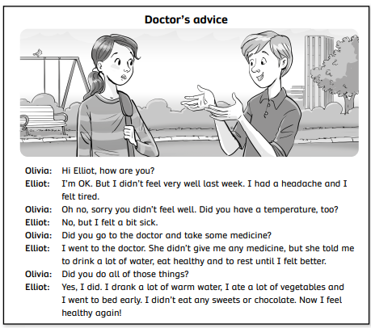

1. Answer the questions:

