**MY ENGLISH HOMEWORK: 06/06 - 6° GRADE - SIMPLE – 2025**

**Miss Virginia Grillo**

REVISION: UNIT 2

1. Read the online message about Luis.

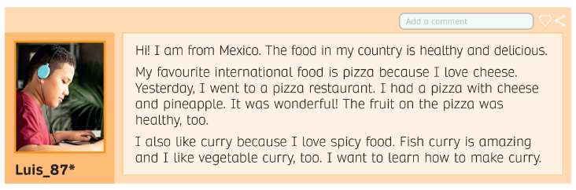

WRITING

