**MY ENGLISH HOMEWORK: 19/06 - 4° GRADE - SIMPLE – 2025**

**Miss Virginia Grillo**

REVISION: UNIT 1

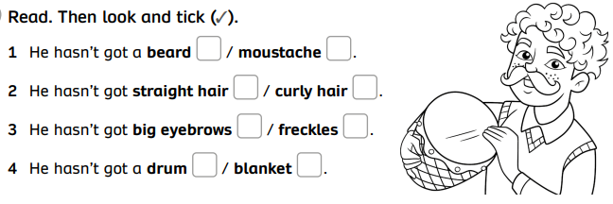

READ THE TEXTS . THEN ANSWER THE QUESTIONS:

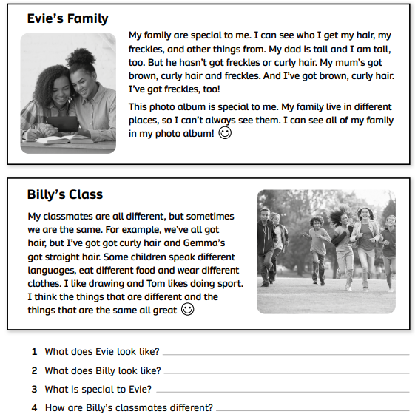

UNIT 2:

