**MY ENGLISH HOMEWORK: 13/06 - 4° GRADE - SIMPLE – 2025**

**Miss Virginia Grillo**

REVISION: UNIT 1 and 2

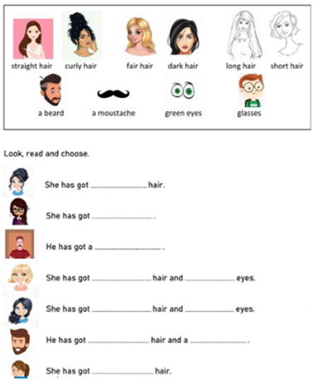

THIS/ THAT/ THESE / THOSE

