MY ENGLISH HOMEWORK: 13/06 - 3° GRADE - SIMPLE – 2025
Miss Virginia Grillo
REVISION: UNIT 1 and 2
ROUTINE ACTIVITIES
- ANSWER THESE QUESTIONS ABOUT YOUR WEEKEND:
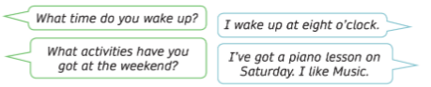
What time do you wake up? _____________________________________
What activities have you got at the weekend? _________________________________________________________________________________________________________________________________________________________
Where do you go? __________________________________________________________

THERE IS/ISN’T – THERE ARE/AREN’T
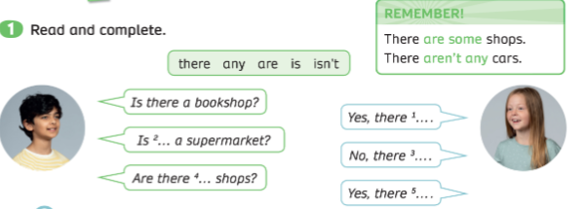
Is there a police officer in your city? __________________________________
Are there any cinemas? _____________________________________________
Is there a town square? ________________________________________________
Are there any hospitals? ________________________________________________

