**June, 19th**

**Homework N°15**

1. **Look at the picture and write 5 deductions. Use must, might/may/could, may not/might not or can’t. Give reasons**

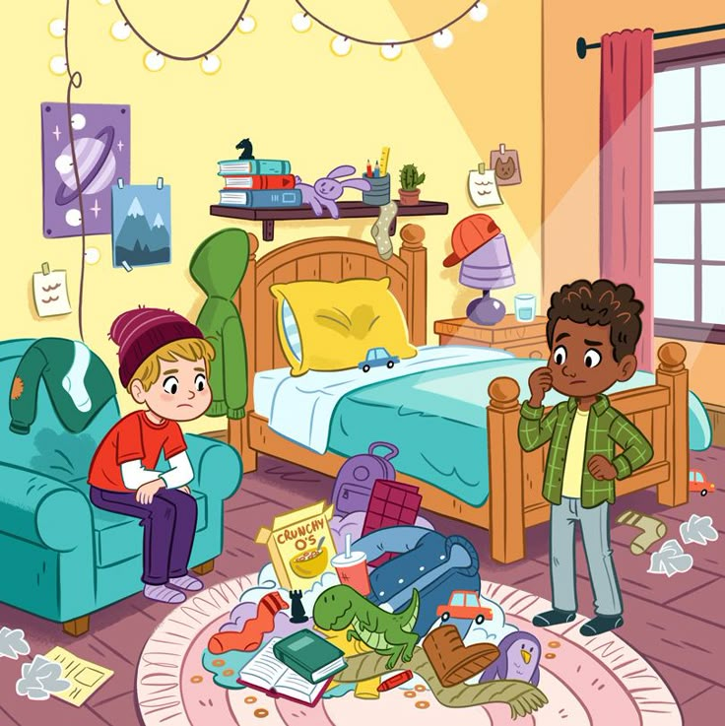

They can’t be siblings because they don’t look alike. ________________________________________________________________________________________________________________________________________________________________________________________________________________________________________________________________________________________________________________________________________________________

1. **Complete the conversation. Use past simple or present perfect.**

A Hey Jamie, __________________________ (you ever / be) to Europe?

B No, I ____________. But I ______________ (travel) to the USA last year.

A Really? Who _______________________ (you / go) with?

B I ___________ (go) with my older sister Patty to Disney.

A Wow, that’s amazing! What _____________________ (you / do) there?

B We ______________ (ride) all the games, ________ (eat) lots of junk food and ________ (see) all our favourite characters.

A ________________________ ( you / take) a photo with Mickey?

B No, we __________. But we ___________ (take) photos with the princesses. They were beautiful! I love Disney princesses.

A How long __________________ (you/be) interested in them?

B Since I _________ (be) a child!