**HOMEWORK JUNE- 1 ° A**

1. **CIRCLE THE CORRECT OPTION**

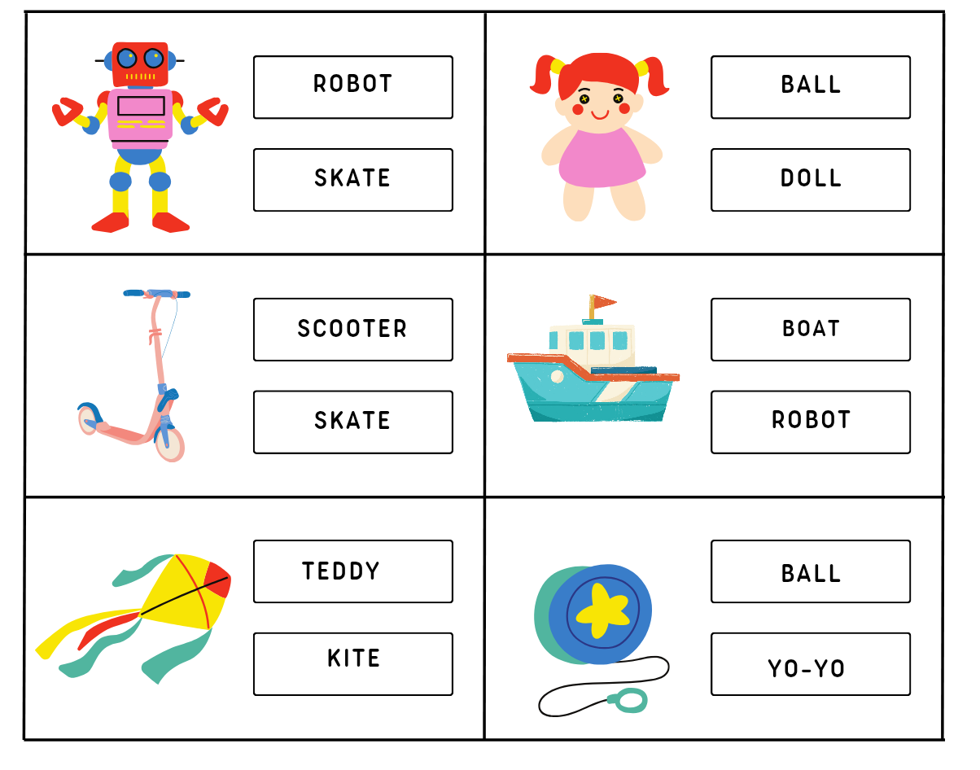

**2) WRITE.**

| **CHEESE - MEAT - EGGS - FISH - MILK - JUICE - RICE - BREAD** |
| --- |

