**HOMEWORK JUNE- 1 ° A**

**1 ) DRAW HAPPY OR SAD. AND WRITE LIKE - DON'T LIKE.**

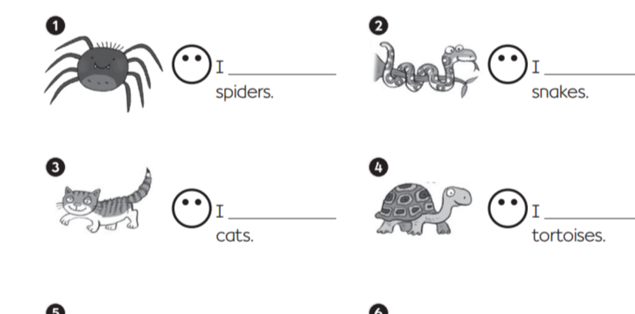

**2) WRITE. YES, I DO. - NO, I DON'T.**

