**HOMEWORK 19 JUNE- 1 ° A**

**READ AND TICK✔️ OR CROSS ✖️**

* I’VE GOT A DOLL
* I'VE GOT A KITE
* I'VE GOT A SCOOTER
* I'VE GOT A TEDDY
* I HAVEN'T GOT A BALL
* I HAVEN'T GOT A BOAT
* I HAVEN'T GOT A SKATEBOARD

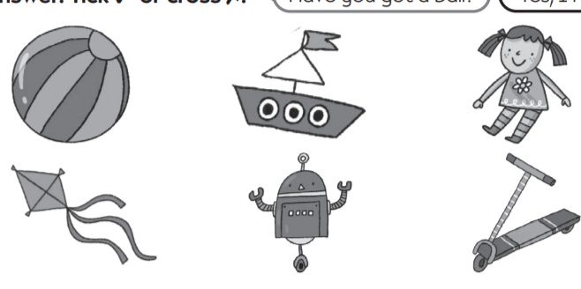

**READ AND DRAW**

* I LIKE CHEESE
* I LIKE MEAT
* I DON'T LIKE CARROTS
* I DON'T LIKE FISH

| 🙂 | ☹️ |
| --- | --- |

**WRITE AND DRAW**

**-I LIKE _____________**

**-I DON'T LIKE ________________**