HOMEWORK JUNE- 1 ° A

1 )READ AND MATCH

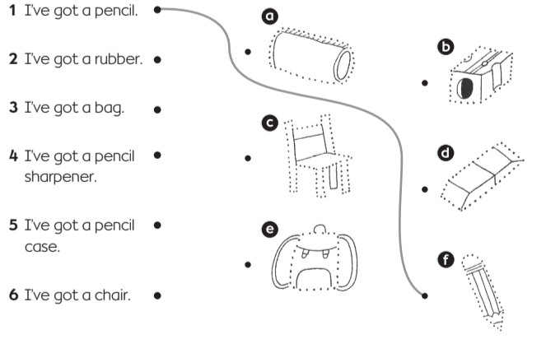

I’VE GOT A PENCIL

I’VE GOT A
PENCILCASE

I’VE GOT A CHAIR

I’VE GOT A BAG

I’VE GOT A
SHARPENER

I’VE GOT A RUBBER
2) READ AND MATCH

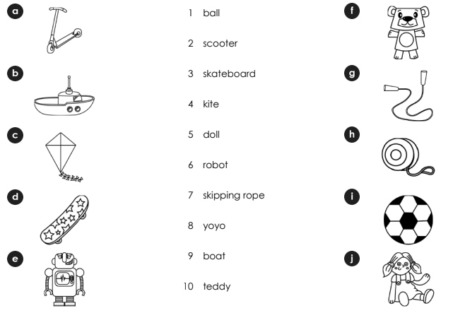

ROBOT
YOYO
BALL
DOLL
BOAT
SKATEBOARD
SCOOTER
TEDDY
KITE
SKIPPING ROPE

3) COMPLETE
TOMATOES - SANDWICHES - STRAWBERRIES - LETTUCE - MILK

