**MY ENGLISH HOMEWORK: 30/05 - 3° GRADE - SIMPLE – 2025**

**Miss Virginia Grillo**

REVISION: UNIT 2

1. Read the text about Molly’s city.
2. Underline: - with BLUE: sentences with THERE IS and THERE ISN’T

* With RED: sentences with THERE ARE and THERE AREN’T

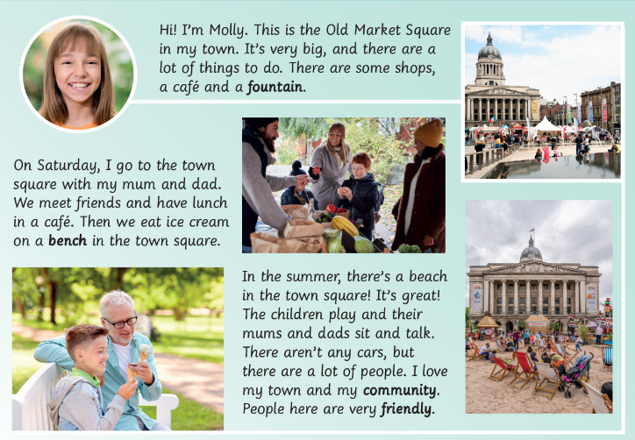

1. Write the sentences:

____________________________________________________________

____________________________________________________________

_____________________________________________________________

______________________________________________________________

______________________________________________________________

1. Underline: - with GREEN: the places of the town.
2. Write the places:

______________________________________________________________

_______________________________________________________________