

Homework nº 8

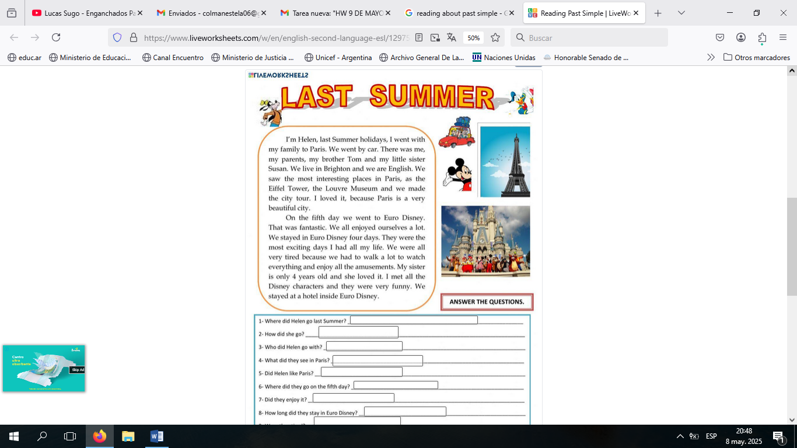

Have a nice week!!!