**Homework: 3rd grade A** – 9th May

* Look at the pictures and write sentences

**IN THE MORNING**

**IIN THE AFTERNOON**

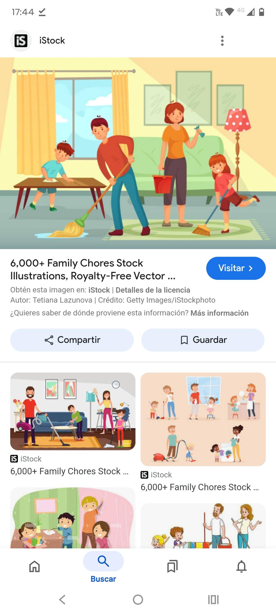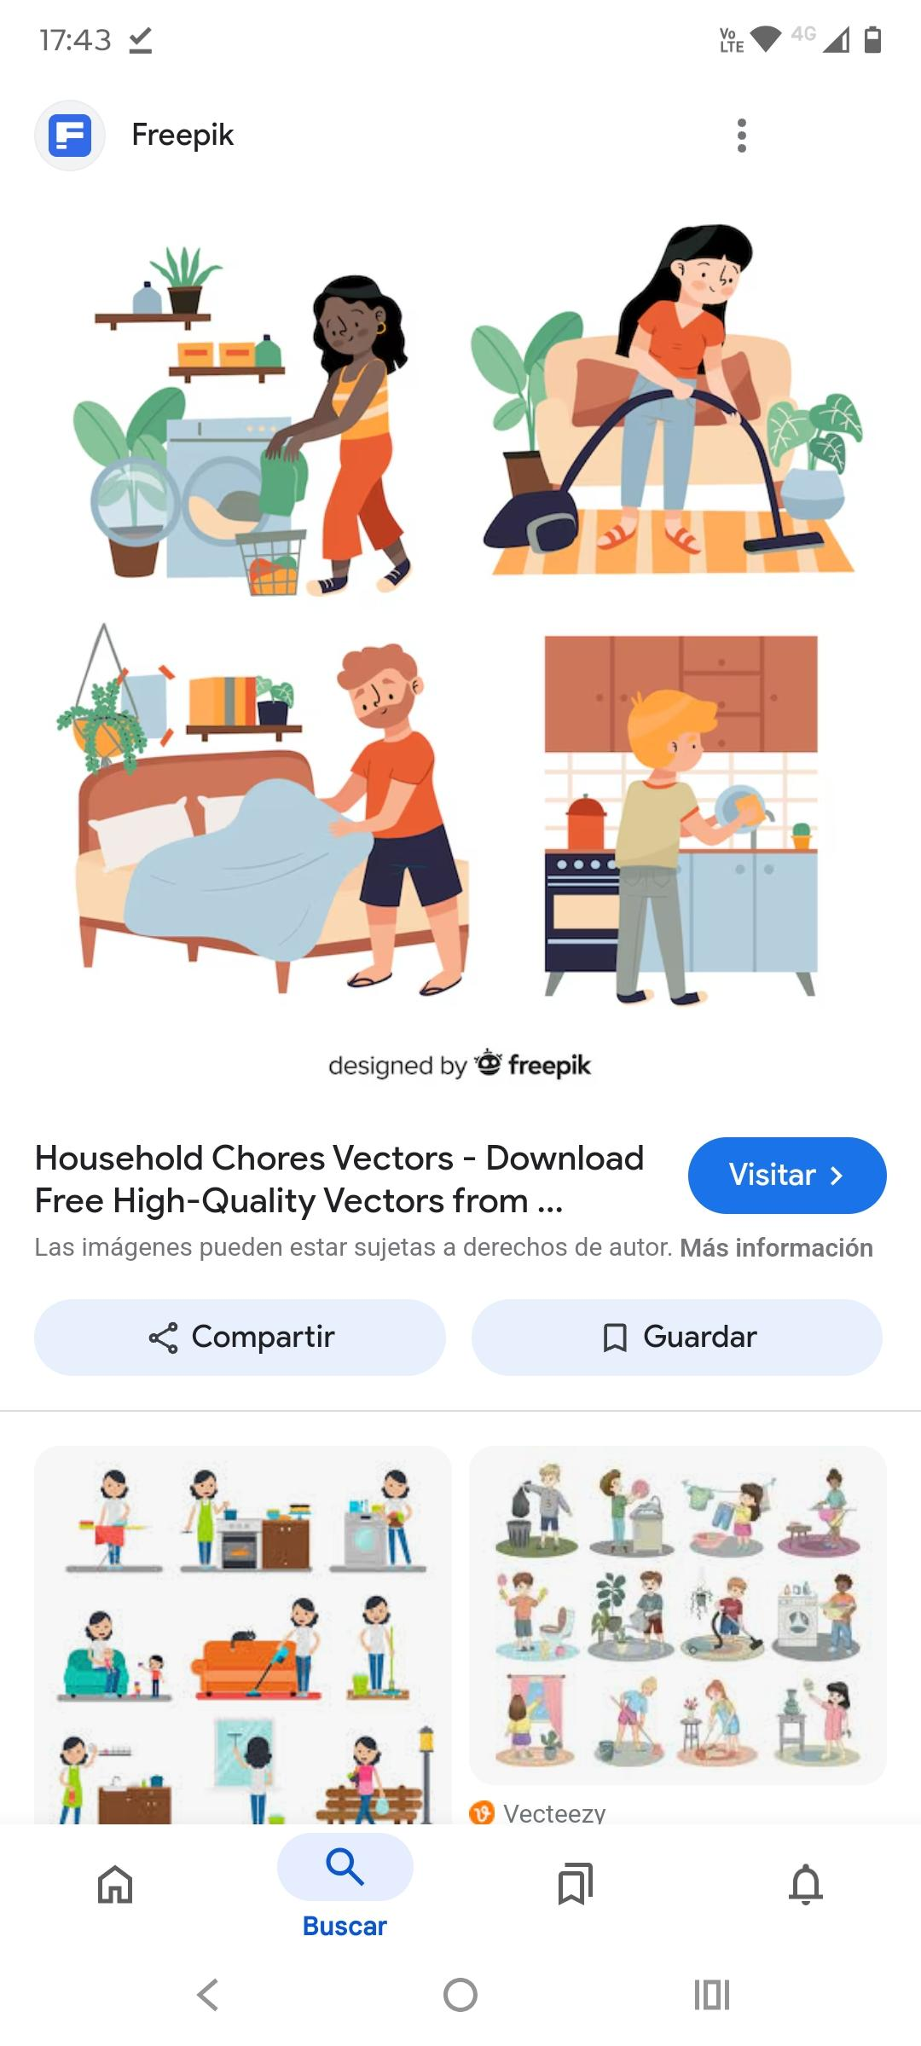

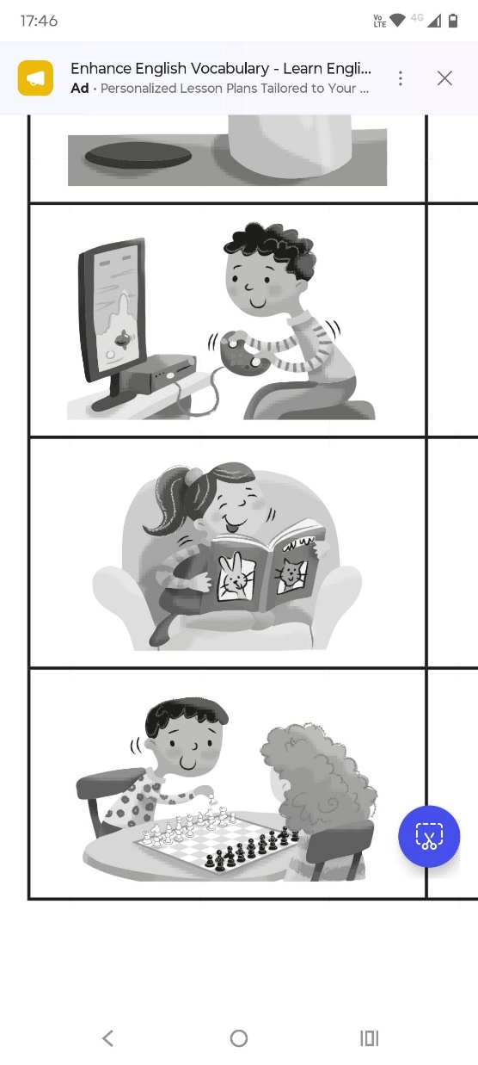

We love the weekends. In the morning we all do _______________. My dad always ____________________. The. My brother Tom ______________________.

My little sister usually ____________________ her toys and I always ________________.

In the afternoon, Tom always _______________________ and then he _____________________ with my little sister. I sometimes _______________ a book.

We love the weekends!!