**HOMEWORK 09 MAY - 1 ° A**

1. **READ AND CIRCLE**

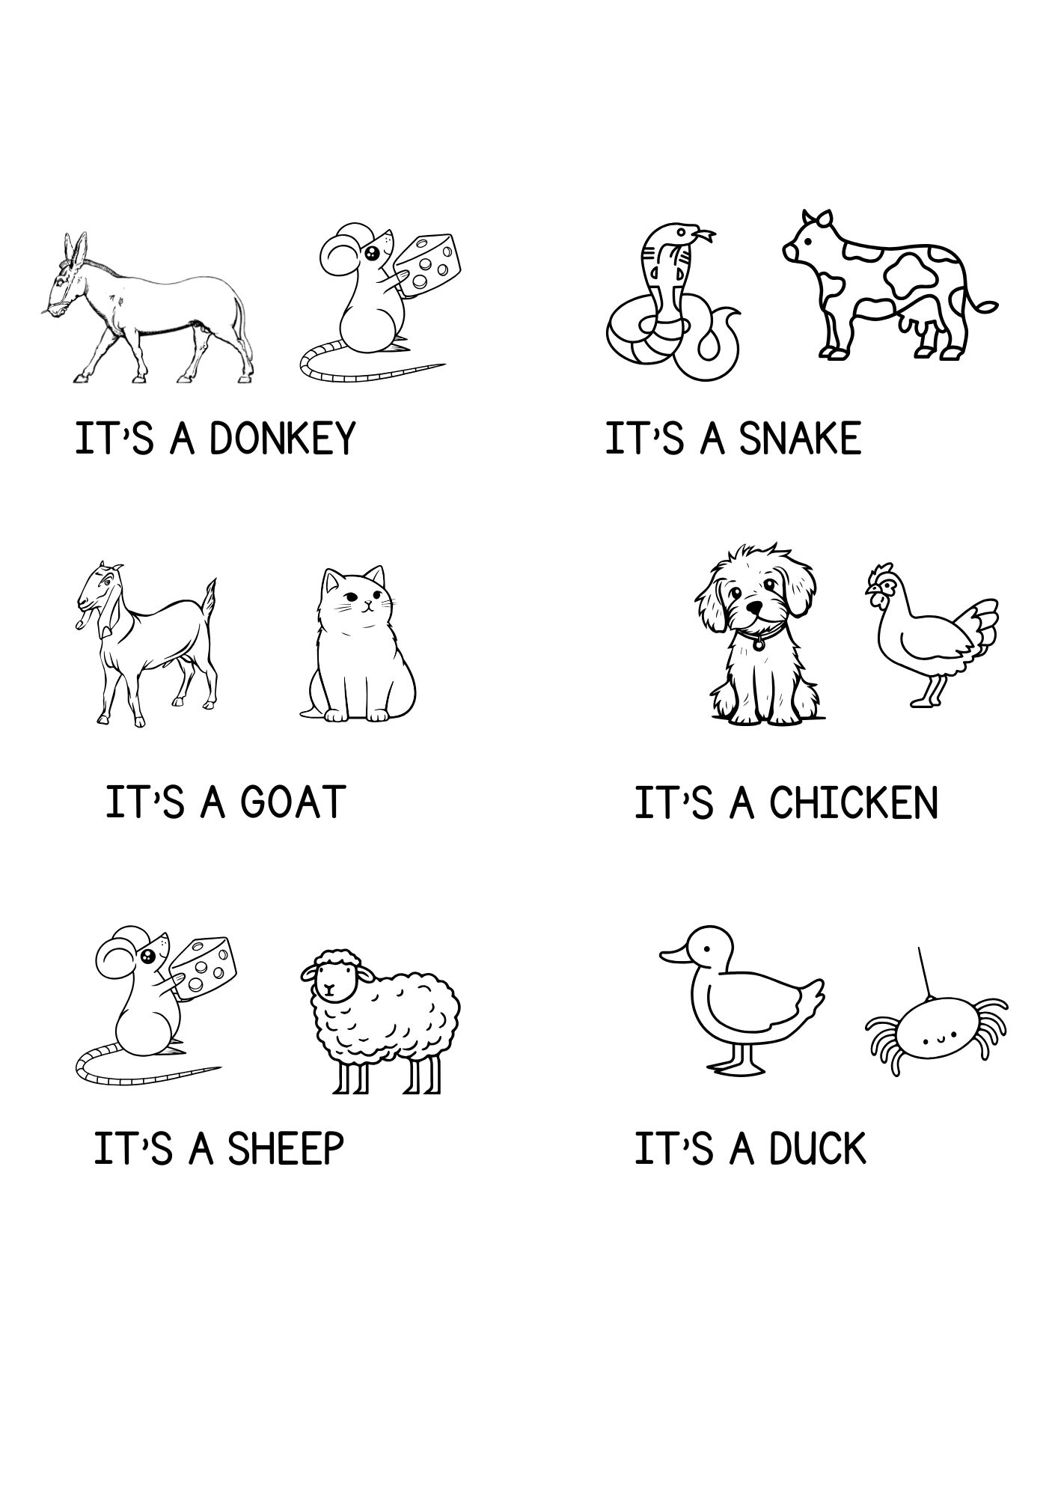

1. **LOOK AND WRITE**

