**Homework 4th grade**

**Teacher: Marianela Blasco Fernández De Moreda**

**Date: March 14th**

1. ***Write the following verbs in past:***
2. Go
3. Fly
4. Walk
5. Study
6. Come
7. Fall
8. Feel
9. Cut
10. Leave
11. Make
12. Have
13. Try
14. Do
15. Bake
16. Lose
17. Buy
18. Play
19. ***Put the frequency adverb or expression in the correct place.***
20. Our teacher is late. (often)
21. Mary has P.E. classes. (twice a week)
22. She goes to the park. (hardly ever)
23. Mike and Gary practice writing. (usually)
24. I am hungry in the morning. (usually)
25. ***Choose the correct option.***

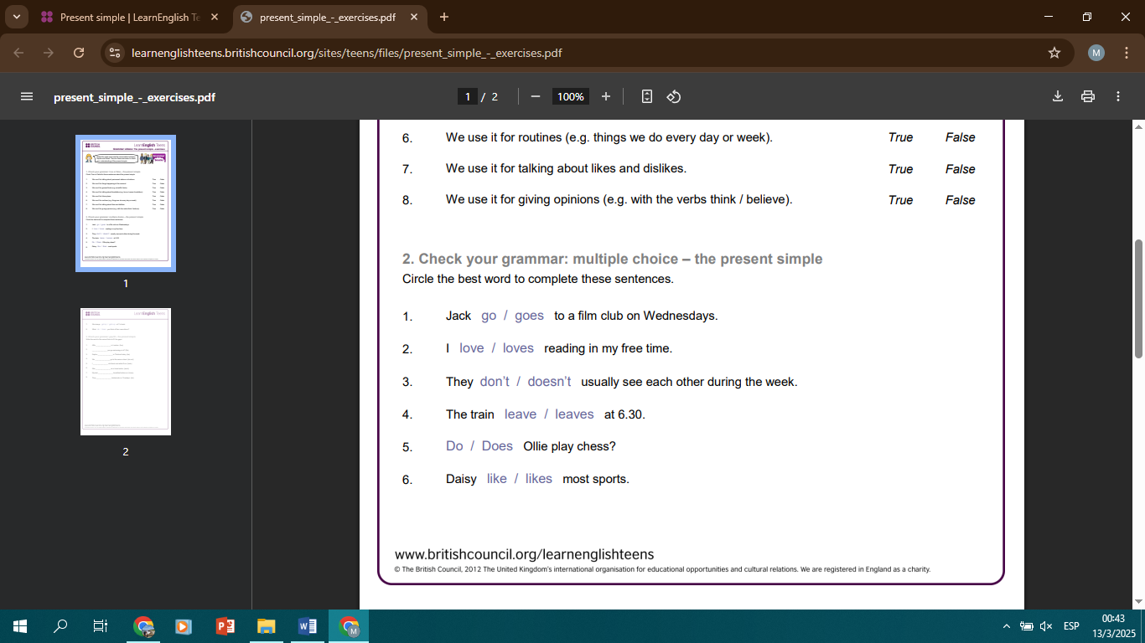

1. ***Complete with there is or there are.***
2. In my house ________________ two stairs.
3. _________________ people in the shop.
4. ________________ a book under the desk.
5. ________________ five chairs around the table.
6. ________________ some birds in the cage.