

**MY ENGLISH HOMEWORK: 14/03 - 2° GRADE – SIMPLE -2025**

**Miss Virginia Grillo**

**REVISION:**

1. WRITE THE WORDS:

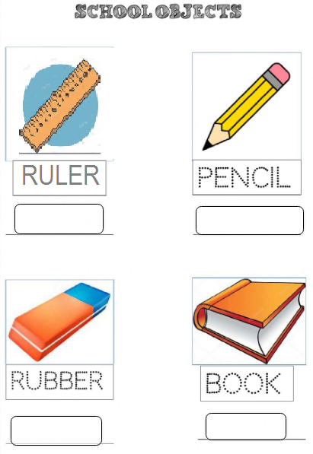

1. READ AND COLOUR:

* N° 2 IS RED
* N° 5 IS GREEN.
* N° 8 IS PURPLE.
* N° 7 IS YELLOW.

