**HOMEWORK 14 MARCH - 1 ° A**

1. **TRACE AND MATCH**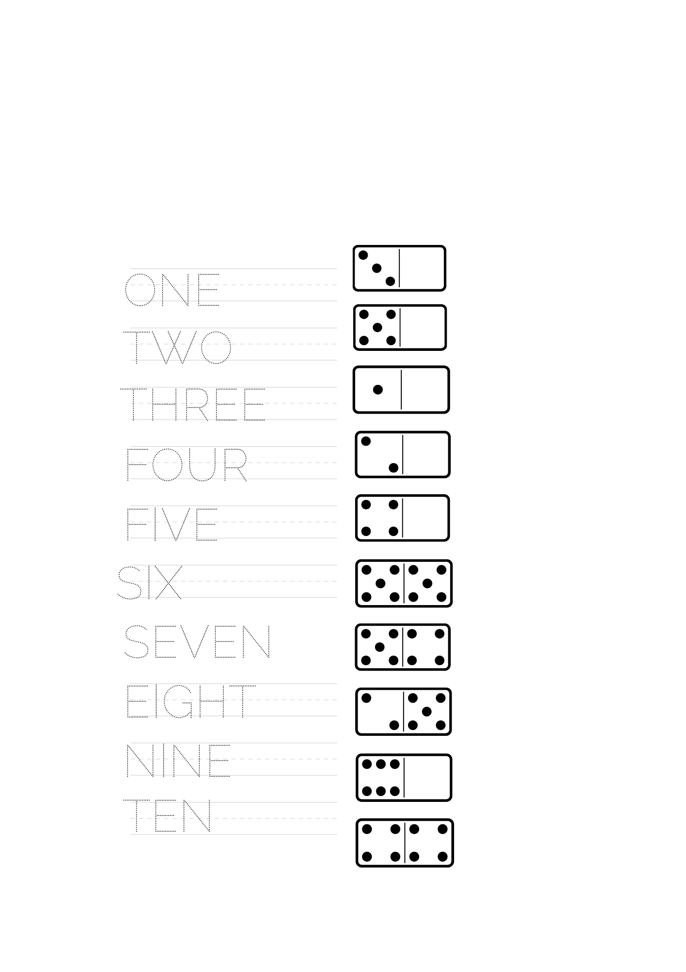
2. **TRACE AND COLOUR**