

HOMEWORK N° 3 28/03

1. Open the link, read the text and complete the activities.

<https://www.liveworksheets.com/w/en/english-language/2250777>

1. Read and study.

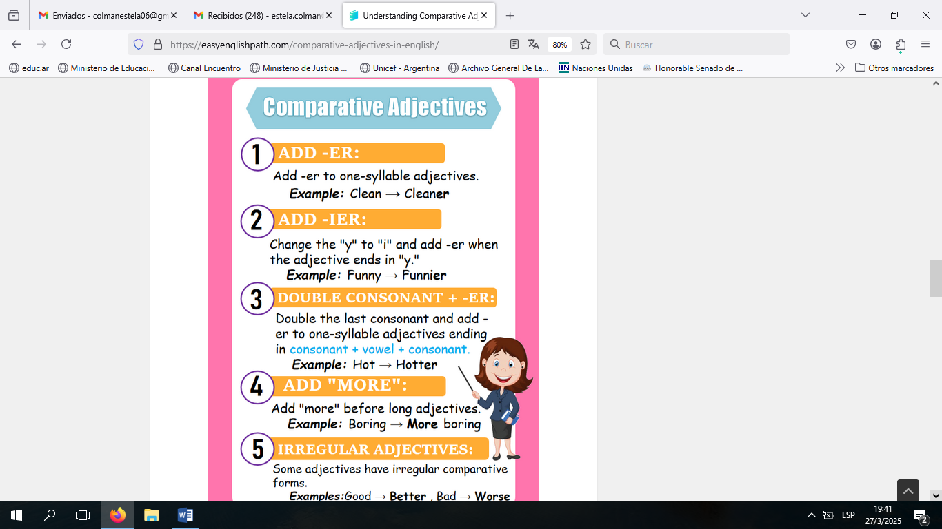

3)

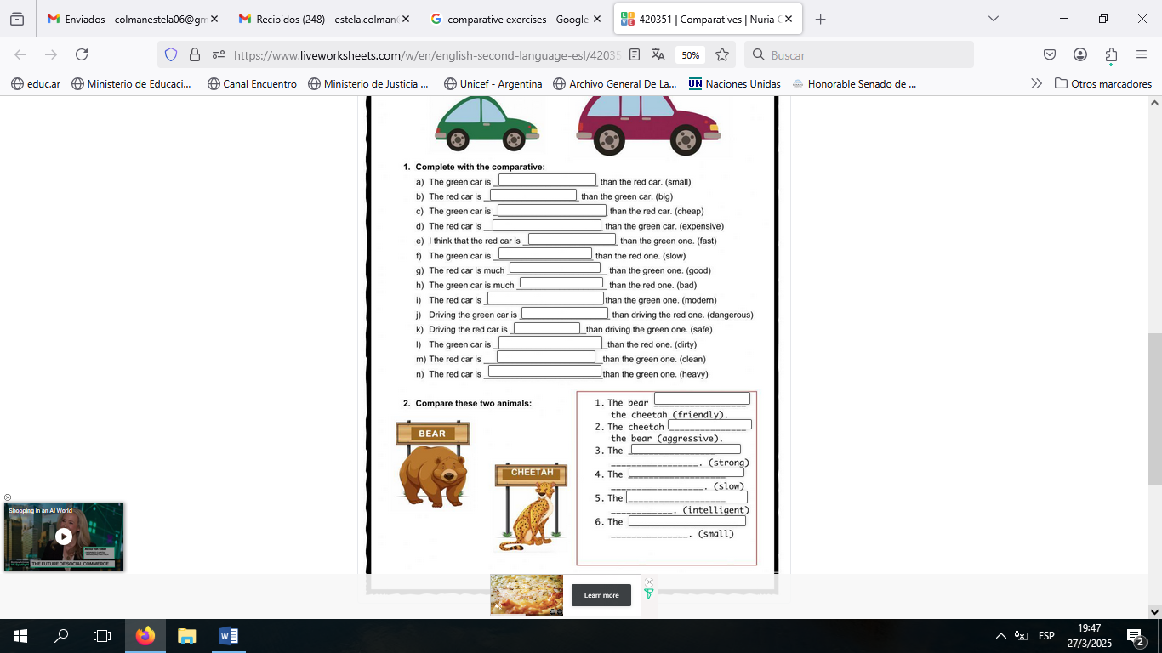

Have a nice weekend!!!